**Practical 2**

**SRS TABLE OF CONTENTS**

| **Sr no** | **Title** |
| --- | --- |
| **1.** | **Introduction** |
| 1.1 | Purpose |
| 1.2 | Scope |
| 1.3 | Technologies used |
| 1.4 | Project requirements |
| 1.5 | Definition of problem |
| 1.6 | Feasibility study |
| **2.** | **Functional requirements** |
| 2.1 | Modules and its descriptions |
| 2.2 | Uml diagrams |
| 2.3 | Er diagrams |
| **3.** | **Non functional requirements** |
| 3.1 | Goals of purposed system |

**INTRODUCTION**

**Purpose:**

* This project is aimed at developing a Web application that depicts online Shopping of mobiles and purchasing using Payment Gateway.
* Using this software, companies can improve the efficiency of their services. Online Shopping is one of the applications to improve the marketing of the company's products. This web application involves all the features of an online shopping website.
* The main purpose of the Online Mobile Shop System is to help customer to find different mobiles, their features, and new updates easily. It is designed such a way that one can view all the updates of the mobile from any place through online. This document will contain the functional requirements of the project andhow the developers will enhance the project to achieve all the objectives.

**Scope:**

* This system will reduce the manual operation required to maintain all the records of booking information. And also generates the various reports for analysis. Main concept of the project is to enter transaction reports and to maintain customer records. Hence this software can be used in any mobile showroom to maintain their record easily.

**Technologies Used:**

* The project will be an Online Mobile Shop System Based on Web Application to be developed in ASP.Net and C# as Back Code and having SQL SERVER as back end.
* **Front End & Coding**
  + Form Design (ASP.NET, HTML)
  + Back Coding (C#)
  + Testing (ASP.NET, C#)
* **Back end**
  + Database Design (SQL SERVER 2012)

Project requirements

The minimum hardware and software requirements for our project are:

* **Hardware Requirements**
  + System: Pentium IV 2.4 GHz
  + Hard disk: 40 GB
  + RAM: 512 MB
* **Software Requirements**
  + Operating system: Windows XP, 7, 8.1, 10
  + Technology: Microsoft Visual Studio .Net 2010
  + Coding Language: C#
  + Back End : SQL Server 2012

**Definition of Problem**

* The project Online Mobile Shop System deals with the problems on managing User registration and buying mobile phones and avoids the problems which occur when carried manually. There are a lot of repetitions which can be easily avoided.
* And hence there is a lot of strain on the person who are running the shops and software's are not usually used in this context.
* Identification of the drawbacks of the existing system leads to the designing of computerized system that will be compatible to the existing system with the system which is more user-friendly.
* We can improve the efficiency of the system, thus overcome the drawbacks of the existing system.

**Feasibility Study**

* The feasibility of the project is analyzed in this phase and business proposal is put forth with a very general plan for the project and some cost estimates.
* During system analysis the feasibility study of the proposed system is to be carried out. This is to ensure that the proposed system is not a burden to the company.
* For feasibility analysis, some understanding of the major requirements for the system is essential.
  + Economic feasibility
  + Technical feasibility
  + Social feasibility
* **Economic Feasibility**
  + Economic analysis is the most frequently used method for evaluating the effectiveness of a candidate system. More commonly known as cost/benefit analysis, the procedure is to determine the benefits and savings that are expected from a candidate system and compare them with costs.
  + If benefits outweigh costs, then the decision is made to design and implement the system.
* **Technical Feasibility**
  + This involves questions such as whether the technology needed for the system exists, how difficult it will be to build, and whether the firm has enough experience using that technology. The assessment is based on an outline design of system requirements in
  + terms of Input, Processes, Output, Fields, Programs, and Procedures.
  + This can be quantified in terms of volumes of data, trends, frequency of updating, etc in order to estimate if the new system will perform adequately or not.
* **Social Feasibility**
  + Determines whether the proposed system conflicts with legal requirements, (e.g. a data processing system must comply with the local data protection acts).
  + When an organization has either internal or external legal counsel, such reviews are typically standard. However, a project may face legal issues after completion if this factor is not considered at this stage. It is about the authorization.

**FUNCTIONAL REQUIREMENTS**

**Modules and its Descriptions:**

The modules used in this software are as follows:

* Login: This module has a drop down list box from where we have to select ADMIN or USER. The ADMIN has all the rights in the software including updating the status of his site. The other fields in login are username and password. If the username and password are correct then it is directed to next page.
* New user: This module is for the users who do not have their account. Here user is allowed to create an account to login. The account creation is done by filling the registration form with user details such as name, phone, email etc.
* Product: This module has information regarding the mobiles such as its name, model, color, price information, and its features etc. The ADMIN has the authority to Add, Delete, and Update etc. The USER can only view the Mobile, add to cart only those in the stock etc.
* Accessories: This module consists of various available accessories of the Mobile with its name and picture, price information etc.
* Search: This module helps the customer to ease his search based on his budget or interest. The search can be done on different categories like mobile model name, model number, colour, price etc.
* Cart: User can select any number of Mobile and add to the cart. He can also remove from the cart if he dislikes it later.
* Payment: This module describes the payment done by the customer. The payment information can include information like the model purchased, quantity, mode of payment (cash, loan) etc.
* Stocks: This gives the details regarding the products available for sale.

**UML Diagrams**

* The Unified Modeling Language (UML) is a standard language for specifying, visualizing, constructing, and documenting the artifacts of software systems, as well as for business modeling and other non-software systems.
* The UML represents a collection of best engineering practices that have proven successful in the modeling of large and complex systems. The UML is a very important part of developing objects-oriented software and the software development process.
* The UML uses mostly graphical notations to express the design of software projects. Using the UML helps project teams communicate, explore potential designs, and validate the architectural design of the software.

**Goals of UML**

The primary goals in the design of the UML were:

(1) Provide users with a ready-to-use, expressive visual modeling language

so they can develop and exchange meaningful models.

(2) Provide extensibility and specialization mechanisms to extend the core concepts.

(3) Be independent of particular programming languages and development processes.

(4) Provide a formal basis for understanding the modeling language.

(5) Encourage the growth of the OO tools market.

(6) Support higher-level development concepts such as collaborations. frameworks, patterns and components.

(7)Integrate best practices.

We will see the uml diagrams in the next practical

**ER Diagrams**

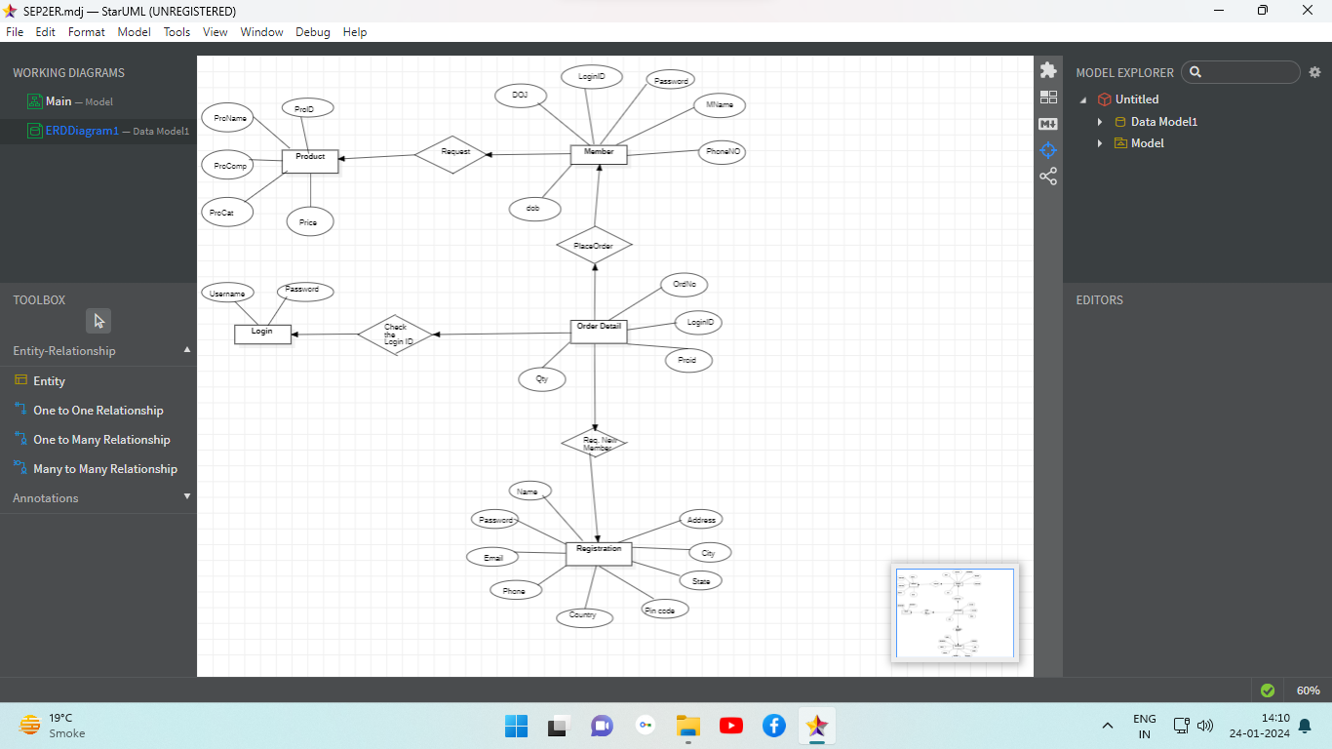

**NON FUNCTIONAL REQUIREMENT**

**Goals of Proposed System:**

1. **Planned approach towards working:** The working in the organization will be well planned and organized. The data will be stored properly in data stores, which will help in retrieval of information as well as its storage.
2. **Accuracy:** The level of accuracy in the proposed system will be higher. All operation would be done correctly and it ensures that whatever Information is coming from the center is accurate.
3. **Reliability:** The reliability of the proposed system will be high due to the above stated reasons. The reason for the increased reliability of the System is that now there would be proper storage of information.
4. **No Redundancy:** In the proposed system utmost care would be that no Information is repeated anywhere, in storage or otherwise. This would assure economic use of storage space and consistency in the data stored.
5. **Immediate retrieval of information:** The main objective of proposed System is to provide for a quick and efficient retrieval of information. Any type of information would be available whenever the user requires.
6. **Immediate storage of information:** In manual system there are many Problems to store the largest amount of information.
7. **Easy to Operate:** The system should be easy to operate and should be Such that it can be developed within a short period of time and fit in the Limited budget of the user.
8. **Attractive Graphical User Interface:** The system is designed to have a Rich and attractive graphical interface for better and organized display of Information.